Engineering Tomorrow’s Electric Motors with The Power of 3D Printing

Abstract
Additive Manufacturing (AM) is transforming the production of electrical machine, unlocking innovative design possibilities and a broader range of materials. Join this session to explore cutting-edge insights enabled by 3D printing in the domains of electric windings, thermal management, and manufacturing processes.
Key topics include:
- Copper-free AM-driven Electrical Machines.
- Material trad-off and aluminium windings for high performance and weight-sensitive applications
- How adaptive learning and digitalization facilitate the production of Electric Machines?
- Future directions in the adoption of 3D printing for electrical machine manufacturing

(Optional)

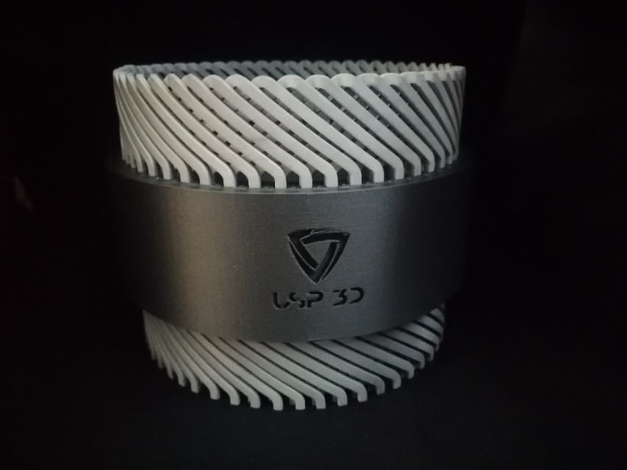
Company: USP3D
webpage: WWW.USP3D.BE

