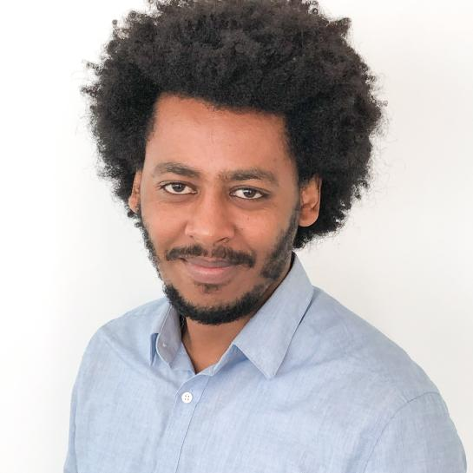
Mesfin Haile Mamme holds a research professor position in Faculty of Engineering, Sustinable Materials Engineering (SUME) research group of Vrije Universiteit Brussel (VUB), Belgium. He is the coordinator of FULL-MAP, one of the groundbreaking EU research project, which brings together over 30 partners from acadamia, research institutes, and industry to redefine materials discovery paradigm. He completed his PhD in Engineering Science at Vrije Universiteit Brussel (VUB) in July 2018, followed by a tenure as an FWO Postdoctoral Fellow from 2020 to 2023. During this period, he conducted research at Université Catholique de Louvain (UCL) at the institute of condensed matter and nanoscience. In 2022, Mesfin undertook a visiting scientist position at Pennsylvania State University, USA.
Mesfin's research endeavours are centred on confronting significant global challenges, encompassing the surge in energy demand, the depletion of fossil fuels, the exacerbation of global warming due to CO₂ emissions, vulnerabilities related to critical raw materials, and the potential for unforeseen and catastrophic failures in infrastructure (such as bridges and buildings). His primary focus lies in advanced materials discovery and the development of a multifaceted multiscale computational framework, enhanced by artificial intelligence, aimed at predicting, interpreting, and enhancing experimental data. This framework is instrumental in streamlining the discovery and design process of high-performance Materials and electrochemical systems, thereby reducing both cost and time. Increasingly, Mesfin's research agenda gravitates towards advancing various fields of electrochemistry and Materials science, including lithium-ion and beyond batteries, catalysis, fuel cells, and the design and synthesis of advanced functional materials and coatings.

