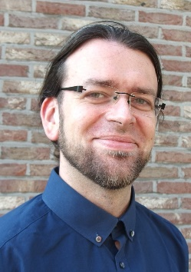**Bio Prof. dr. dr. Danny E.P. Vanpoucke**

**Danny Vanpoucke** (°1980) is an assistant professor at Hasselt University where he heads the **QuATOMs group** (***Quantum & Artificial inTelligence design Of Materials***). He holds **PhDs in Physics** (UTwente, 2005-2009) **and Chemistry** (UGent 2009-2012) for the modelling of nanowires on semiconductor surfaces and defects in cerate buffer layers. After his PhDs, Danny obtained a FWO post-doctoral fellowship (2014-2017) for the modelling of Metal-Organic Frameworks (CMM, UGent). As postdoctoral researcher he studied defects in diamond (IMO, UHasselt, 2017-2019), High-Throughput materials design (UGent,2021-2022), and machine learning for coatings and polymers (AMIBM, UM,2019-2020). With his interdisciplinary background, Danny explores the interface between theory and experiment, always looking for new challenges in materials modelling, resulting in **56 peer-reviewed publications** (4 being cover publications). His QuATOMs team explores the materials realm around the research vision of high accuracy characterization of materials at the atomic scale, using quantum chemical techniques accelerated by means of artificial intelligence. Although his focus and expertise is purely theoretical, he always tries to make the connection with experiment, which can be seen in over **20 experimental-theoretical research papers and research-collaborations** (e.g. Digilignin project focussing on the modelling of lignin, with VITO & UMaastricht).

Danny is also strongly involved in the **Master in Materiomics program** (interdisciplinary Master in physics/chemistry of materials) for which he developed the theoretical pillar and now is an active member of its educational management team. He currently teaches 7 theory oriented **courses from quantum chemistry to High-Throughput modelling and application of AI in materials research** (as well as contributions to other courses). He is/was the promotor of many computationally oriented (AI/DFT) internships, BSc and MSc thesis’s. His principal aim in education is to create awareness of the potential of computational research, through hands-on practical experience with computer labs in quantum chemistry and artificial intelligence.