Professor Sara Bals

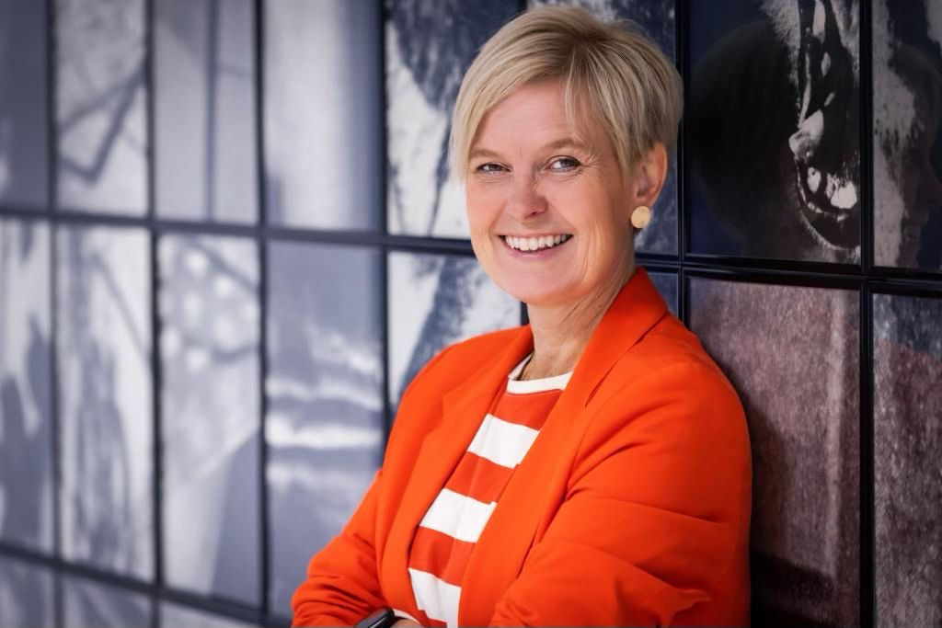

Sara Bals was born in Antwerp (Belgium) in 1977 and studied Physics at the University of Antwerp from 1995-1999. She obtained her PhD in 2003 with greatest distinction and special honours by the jury. From 2003-2004, she did postdoctoral work at the National Center of Electron Microscopy in Berkeley, USA. The focus of her work was the development of electron tomography for materials science. After returning to UAntwerp, she became an Assistant Professor in the Physics Department. In 2018 she was promoted to Full Professor. She is currently the spokesperson of EMAT, consisting of 7 principal investigators, about 25 postdoctoral researchers and more than 30 PhD students. Moreover, she is the coordinator of the “Nanolab” Centre of Excellence at the host institution, composed of 6 research groups. Sara Bals is an expert in the application and development of electron tomography for functional nanomaterials. By combining state-of-the-art electron microscopy with advanced 3D reconstruction algorithms, the positions and chemical nature of individual atoms in a nanomaterial are measured. These measurements are now also performed under realistic conditions (heating, liquid or gas flow experiments). She was awarded an ERC Starting grant in 2012, an ERC Consolidator grant in 2018, an ERC Proof of Concept grant in 2023 and an ERC Synergy grant in 2025. She received the award "Laureate of the Academy for Natural Sciences" by the Royal Flemish Academy in 2016, became Francqui research professor in 2017 and was elected as member of the Royal Flemish Academy of Belgium for Science and the Arts in 2020. She received the European Microscopy Award in 2020 and the ACS Nano Lectureship award in 2021. She is an elected member of the European Academy of Sciences and the Academia Europaea. Since 2023 she is Associate Editor with ACS Nano.

